Dimensionality Reduction
- What is it?
Dimensionality reduction is the process of reducing the number of features (variables) in a dataset while retaining as much important information as possible.
- Why do we need it?
  - Simplify Models: Too many features can make models complex and harder to interpret.
  - Reduce Noise: Some features may be irrelevant or redundant.
  - Avoid Overfitting: High-dimensional data can lead to overfitting.
  - Efficiency: Fewer features mean faster computation and easier visualization.

Table of Contents
PCA (Principal Component Analysis) 1
Factor Analysis 1
Scaling Dimensional Model 2
LDA (Linear Discriminant Analysis) 2

PCA (Principal Component Analysis)
- What is it?
PCA is a technique that transforms the data into a new set of features called "principal components." These components are linear combinations of the original features, arranged so that the first few components capture most of the variability in the data.
- Why use PCA?
  - Identify patterns in data.
  - Reduce dimensions without losing much information.
  - Prepare data for visualization (e.g., plotting high-dimensional data in 2D or 3D).
- How does it work? PCA finds directions (axes) in the feature space where the variance (spread) of the data is maximum. These axes are the principal components.

Factor Analysis
- What is it?
Factor Analysis is similar to PCA but focuses on modeling the underlying structure in the data. It assumes that observed variables are influenced by a smaller number of unobserved (latent) factors.
- Why use it?
  - Discover hidden relationships between variables.
  - Reduce dimensions while interpreting the underlying factors that explain the data.
- Key Difference from PCA:
While PCA focuses on maximizing variance, Factor Analysis focuses on explaining the correlations between variables.

Scaling Dimensional Model
- What is it?
Scaling ensures that all features in a dataset contribute equally to the analysis. It’s particularly important in dimensionality reduction because methods like PCA are sensitive to differences in the scale of features.
- Why scale?
  - Features with large ranges can dominate the results.
  - Ensures a fair comparison between features.
- Methods:
  - Standardization: Rescales data to have a mean of 0 and a standard deviation of 1.
  - Normalization: Rescales data to range between 0 and 1.

LDA (Linear Discriminant Analysis)
- What is it?
LDA is a dimensionality reduction technique primarily used for supervised learning. It reduces dimensions while maximizing the separation between classes in the data.
- Why use LDA?
  - Enhance class separability.
  - Improve classification accuracy.
- How does it work? LDA finds a linear combination of features that best separates two or more classes. It reduces dimensions while keeping the most discriminative information.
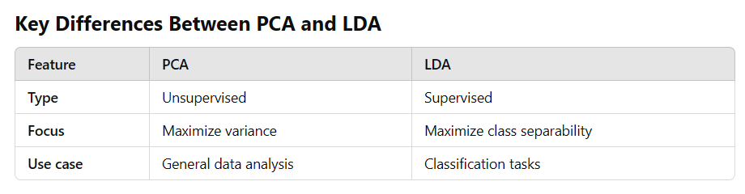
In summary, dimensionality reduction is essential for simplifying data, improving efficiency, and preventing overfitting. Techniques like PCA, Factor Analysis, and LDA serve different purposes based on whether you're exploring the data or focusing on supervised tasks. Scaling is a preparatory step to ensure fair treatment of features during these analyses.

What is the Curse of Dimensionality?
The "curse of dimensionality" refers to the challenges and problems that arise when working with high-dimensional data (datasets with many features). As the number of dimensions (features) increases, the data tends to become sparse, and the performance of algorithms often deteriorates.

Why is it a Curse?
- Increased Computational Complexity
High-dimensional data requires more computation and memory, making it slow to process and analyze.
- Overfitting in Machine Learning
With too many features, models can memorize the training data instead of learning general patterns, leading to poor performance on new, unseen data.
- Data Sparsity
In high dimensions, data points become sparse and are far apart from each other. This sparsity makes it hard for algorithms to find meaningful patterns or clusters.
- Distance Measures Lose Meaning
Many machine learning algorithms rely on distance metrics (e.g., Euclidean distance). In high dimensions, the differences between distances become negligible, making it hard to differentiate between points.
- Visualization Challenges
It’s nearly impossible to visualize data in more than three dimensions, making interpretation difficult.

How Dimensionality Reduction Helps with the Curse
- Simplifies the Dataset
Reducing the number of dimensions helps eliminate redundant or irrelevant features, making the data more manageable.
- Focuses on Key Features
Techniques like PCA retain the most important information while discarding noise or less significant variations.
- Improves Model Performance
By reducing dimensions, models are less likely to overfit and can generalize better.
- Reduces Computation Time
Fewer dimensions mean faster training and prediction times for machine learning models.

Real-World Analogy
Imagine you're trying to find your way in a maze. If the maze has only two dimensions (width and length), it's manageable. But if the maze has ten dimensions (width, length, height, time, etc.), it becomes almost impossible to navigate. Dimensionality reduction simplifies the maze, so you can focus on the most important paths.

Dimensionality reduction methods like PCA, LDA, and Factor Analysis are powerful tools to combat the curse of dimensionality, ensuring that we can work with high-dimensional data effectively and efficiently.

PCA (Principal Component Analysis)
- Core Idea:
PCA reduces the dimensionality of data by identifying new axes (principal components) that maximize the variance in the data while keeping these axes orthogonal (uncorrelated).
- Key Concepts:
  - Maximum Variance: The first principal component captures the direction of the highest variance in the data.
  - Subsequent Components: Each successive component captures the next highest variance, while being orthogonal to (independent of) the previous ones.
  - Variance Preserved: The total variance of the data is preserved, distributed across the principal components.
- Steps:
  - Compute the covariance matrix of the data.
  - Find the eigenvalues and eigenvectors of this covariance matrix.
  - Select the top k eigenvectors (corresponding to the largest eigenvalues) as the new axes.
  - Transform the data onto these new axes.
- Eigenvalues and Scree Plot:
  - Eigenvalues: Indicate the amount of variance explained by each principal component.
  - Scree Plot: A graph of eigenvalues sorted in descending order. The "elbow" point in this plot helps identify the optimal number of dimensions.
- Applications:
  - Feature reduction while retaining most of the data's variability.
  - Preprocessing for visualization in 2D or 3D.
  - Handling high-dimensional data efficiently.

LDA (Linear Discriminant Analysis)
- Core Idea:
LDA also reduces dimensionality but with a specific goal: maximize class separability. It focuses on finding a projection that best discriminates between multiple classes.
- Key Differences from PCA:
  - PCA: Unsupervised; ignores class labels and focuses on variance.
  - LDA: Supervised; uses class labels to maximize separation between groups.
- Steps:
  - Compute the mean vectors for each class and the overall mean.
  - Calculate the within-class scatter matrix (how data points in the same class scatter) and between-class scatter matrix (how the means of different classes scatter).
  - Solve for the eigenvectors and eigenvalues of the matrix that maximizes the ratio of between-class variance to within-class variance.
  - Select the top k eigenvectors as the new axes.
- Optimal Projection:
  - LDA finds directions (linear discriminants) that maximize the distance between class means while minimizing the scatter within each class.
  - This results in better class separability and reduces overfitting.
- Applications:
  - Multi-class classification tasks where maintaining class separation is critical.
  - Reducing dimensionality in a way that preserves the class-discriminative information.

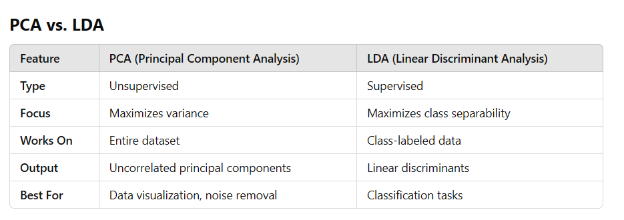

Practical Insight
- Use PCA if:
  - Your goal is dimensionality reduction without worrying about class labels.
  - You want to retain as much variance as possible.
  - You're working with unsupervised data.
- Use LDA if:
  - Your goal is classification and you want to ensure better class separability.
  - You're dealing with supervised data with clear class labels.
Both PCA and LDA can be used sequentially or independently based on your specific problem. For example, you might first use PCA to reduce dimensionality globally and then apply LDA to ensure inter-class separation.
This hybrid approach balances general variance retention with specific class-discrimination.

Selecting the number K in Linear Discriminant Analysis (LDA) refers to determining the optimal number of linear discriminants (dimensions) to retain after the dimensionality reduction step. This is a crucial decision that ensures the model maintains class separability while avoiding overfitting or underfitting.
Here’s how you can approach selecting K:

1. Maximum Possible Number of Linear Discriminants
The maximum number of linear discriminants is:

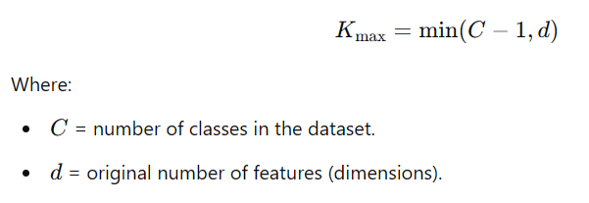
This is because LDA works by finding C−1 axes that maximize class separability in a space spanned by d features.

2. Choose KKK Based on Variance Explained
- Similar to PCA, the eigenvalues in LDA represent the discriminative power (variance explained by each linear discriminant).
- You can compute the cumulative variance explained by the eigenvalues and select the number of discriminants KKK that explains a significant proportion of the variance (e.g., 95%).

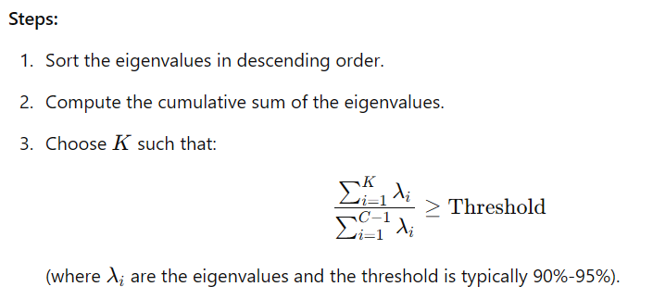

3. Use Cross-Validation
- Perform cross-validation to evaluate the classification performance for different values of K.
- For each K, reduce the dimensions using LDA and train your model.
- Select the K that gives the best cross-validated accuracy or minimizes classification error.

4. Visualize Class Separability
- After reducing the dimensions with LDA, plot the data in 1D, 2D, or 3D (using the top 1, 2, or 3 linear discriminants).
- If the classes are well-separated with fewer dimensions, you can choose KKK based on visual inspection.

5. Application-Specific Goals
- If computational efficiency is a priority, you might limit KKK to a lower number (e.g., 2 or 3), even if higher dimensions offer slight improvement.
- For visualization purposes, KKK is often set to 2 or 3, irrespective of the total dimensions.

